Understanding GPUs

https://medium.com/ai-insights-cobet/understanding-gpu-architecture-basics-and-key-concepts-40412432812b

What is a GPU
- GPUs can best be described as an inverse to CPUs
    - Instead of running complex tasks sequentially, GPUs run smaller tasks across thousands of cores simultaneously
  - CPUs can have limited parallelism, but not nearly to the extent of GPUs

Memory Hierarchy
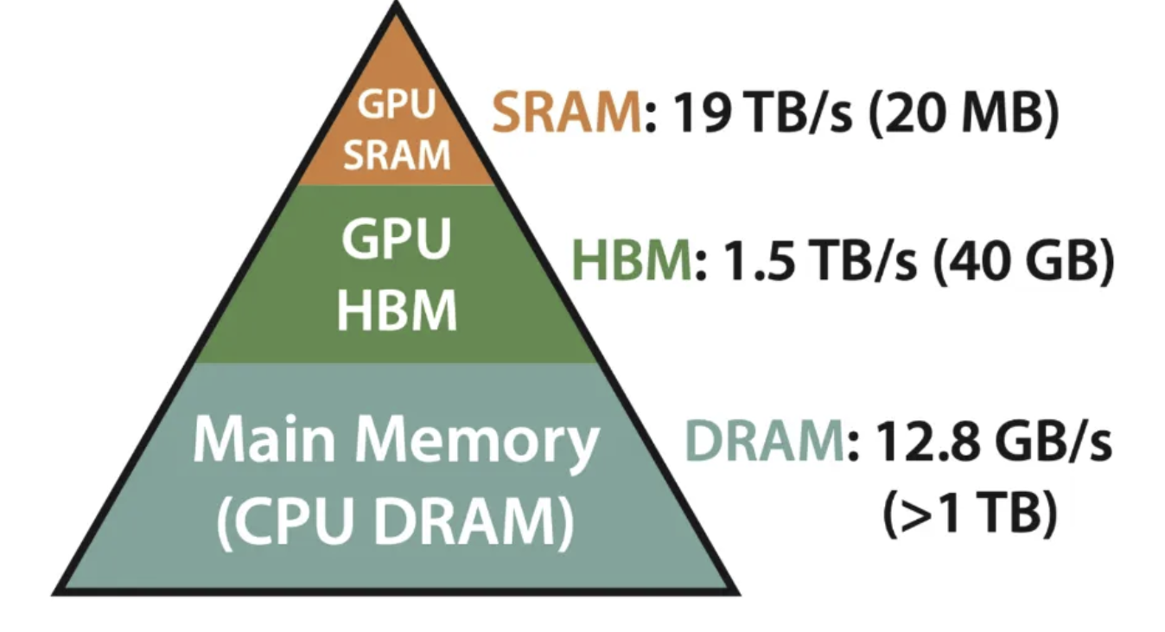

- Split across 3 different sources:
  - SRAM
    - Very fast but small cache memory
    - Located inside GPU, uses Registers, L1 Cache, and L2 Cache
      - L1 Cache
        - First level cache inside Streaming Multiprocessor (SM)
        - Stores frequently accessed data to speed up calculations
      - L2 Chache
        - Larger, second level cache shared between multiple SMs
        - Helps store and reuse data too big for L1 cache
    - Caches reduce reliance on external memory (VRAM) and speed up calculations
    - Optimizing how data is stored speeds up GPU processing
    - Most important for getting the fundamentals of GPU processing working
  - HBM
    - Used in High Performance GPUs for AI and deep learning workloads
    - Stacks memory vertically
    - Overall, lowest priority for a GPU of the scale envisioned
  - DRAM
    - Main memory
    - Found on video card
    - Stores large amounts of data
    - Good to work on once main GPU is figured out
- Memory Transfer
  - Computationally expensive to transfer data from DRAM to SRAM
  - Optimizing efficient memory usage optimizes performance of tasks

Streaming Processors (SMs)
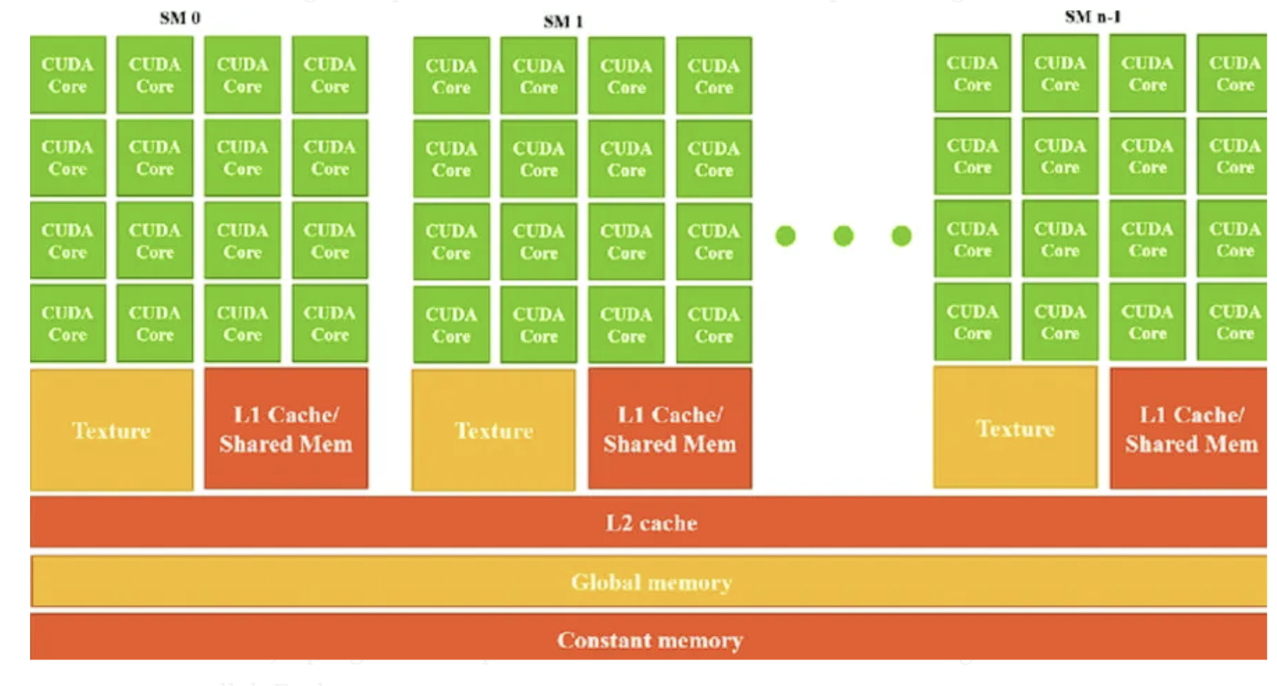

- Fundamental Processing Unit of a GPU
- Each SM contains multiple GPU cores, a small memory pool (SRAM), and execution units
- Each SM operates independently
- GPU computational power directly tied to number of SMs
- Project should implement multiple SMs in parallel
- Programs:
  - Specific instances of kernel code running in parallel
  - Split between SMs
    - Number split between each SM depends on available memory in SM, and memory required by Program
- GPU Cores:
  - Smallest unit of compute
  - Optimized for floating point operations
    - Performs 1 FLOP per cycle
- Warps:
  - Groups of GPU cores
  - All cores in a warp must execute the same instruction simultaneously, but operate on different data

